4.Design Tm For input a^nb^n

DESIGN:

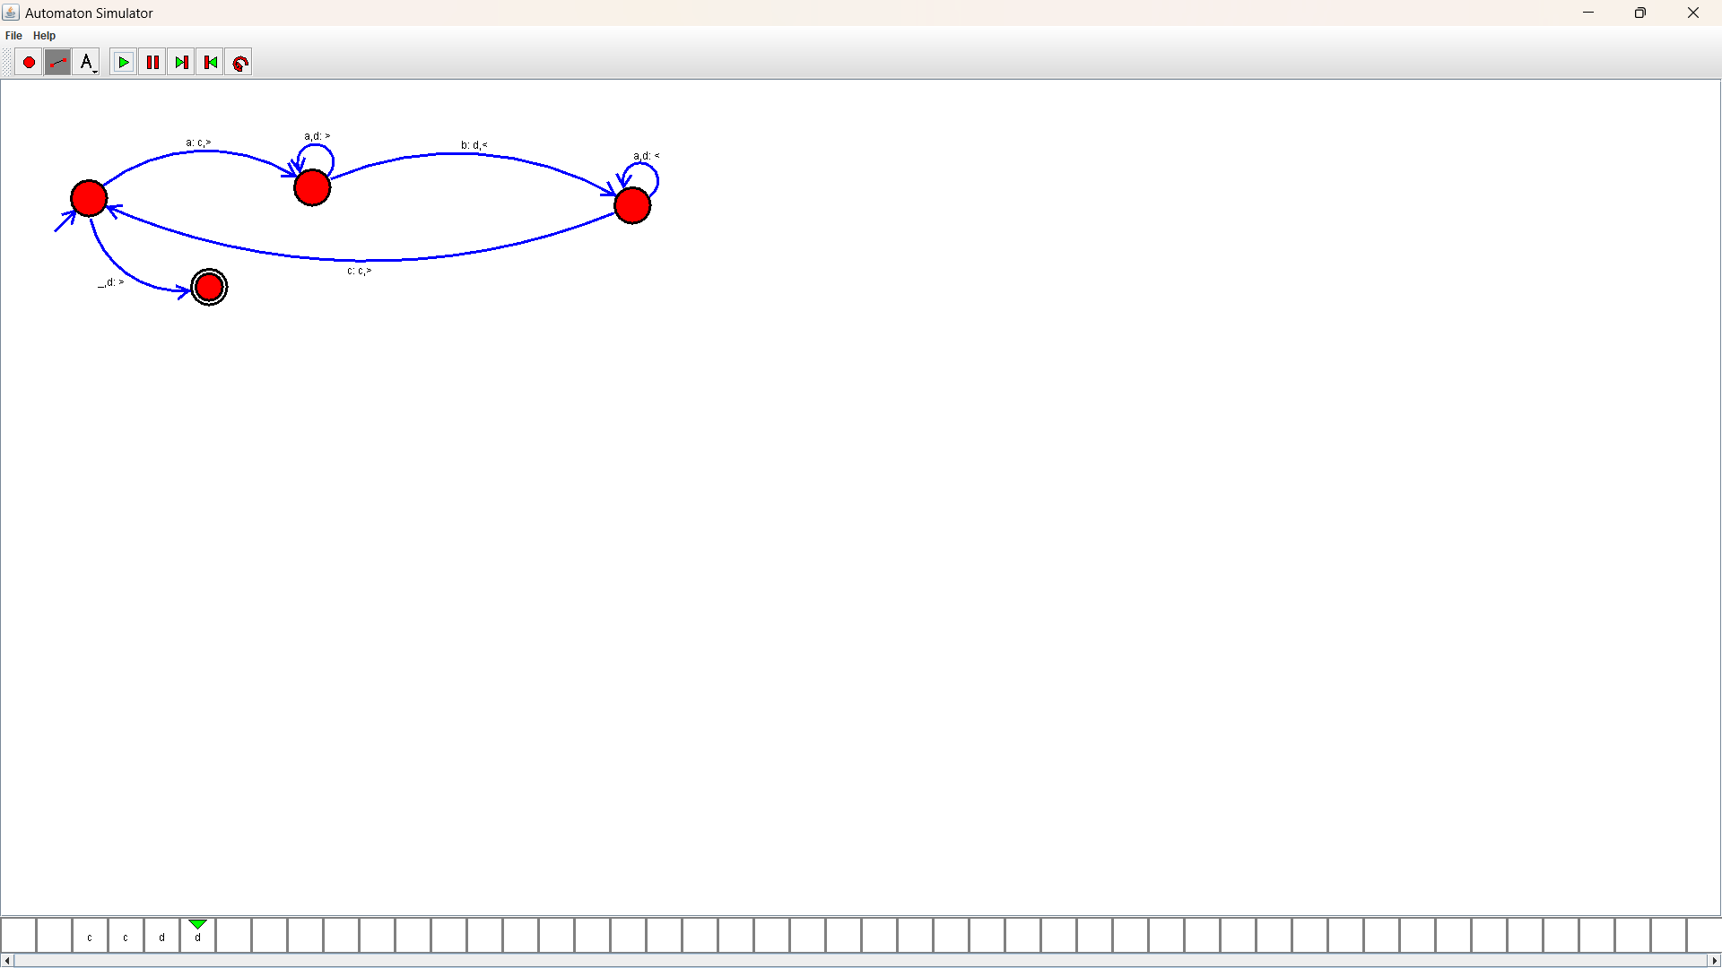

OUTPUT:

